D-SKY University Guide

**Chiranjeevi Raghavendra Yerrajodu**

**Keerthi Yanda**

**Sandeep Ballu**

**Gangadhara Lakshmi Narayana Deepak Kancharla**

**Introduction & Motivation:**

Every new student has to go through the university orientation in which, there will be tour of whole campus of the university. At the same time university management has to find out the volunteers every year and train them to guide the new students and explain about the departments. In order to reduce the manual effort and to avoid human errors in this process, we have developed D-SKY, a robot which will act as a university guide.

We have developed some of the advanced features of the robot which will be helpful in making an interactive robot more effectively. The robot is also able to give the replies to the queries asked by the students. In can also make a call and send a message to the administration team of the college in any emergency situation.

**Related Work:**

In the year 2008, a humanoid robot called JagBot was designed by researchers from university of South Alabama. JagBot vision and speech recognition system, position and tracking system, body, arms, chassis, sensors and control system. Software design has speech, tour, sensors and human-robotic interaction

Also there are many research works on the humanoid robot for different purposes. On these researches basis, we have developed our D-SKY robot for having humanoid interaction I objective c with our database as spark and mongoDB.

Our robot’s hardware is ready made and we have just developed software to function it. We have used ROMO for the bot (base) which is compatible with i-phone5. We have designed an ios application DSKY1 to make the pre designed ROMO as humanoid robot when it is attached with i-phone5.

**Architecture:**

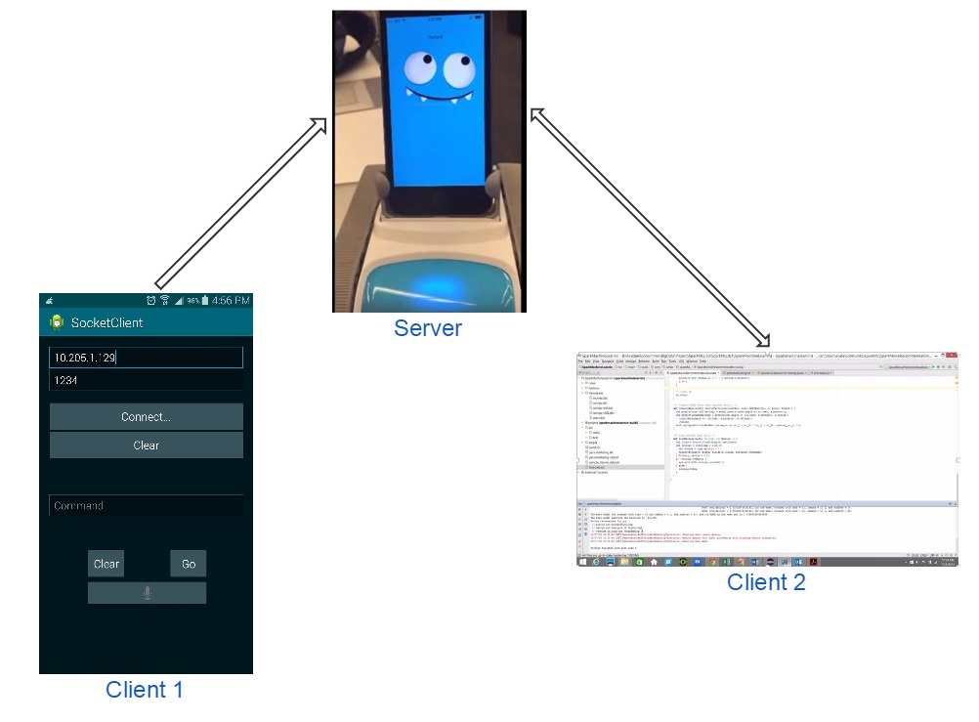

**System Features:**

* Our Robot fetches the current location and if it is known place to our robot, it fetches document from our database about that place and reads it.
* Gives the coordinates for the requested location or address and gives directions too.
* Our Robot can take you along from current to the requested location on the basis of destination coordinates fetched.
* Robot tells the information about the location or building after reaching there.
* Our robot can interact with students. It can respond to some basic questions. If it doesn’t know about the query requested, it responds that it will learn about it.
* Recommend the courses to the students on based of their interests using the data from Spark mongoDB.

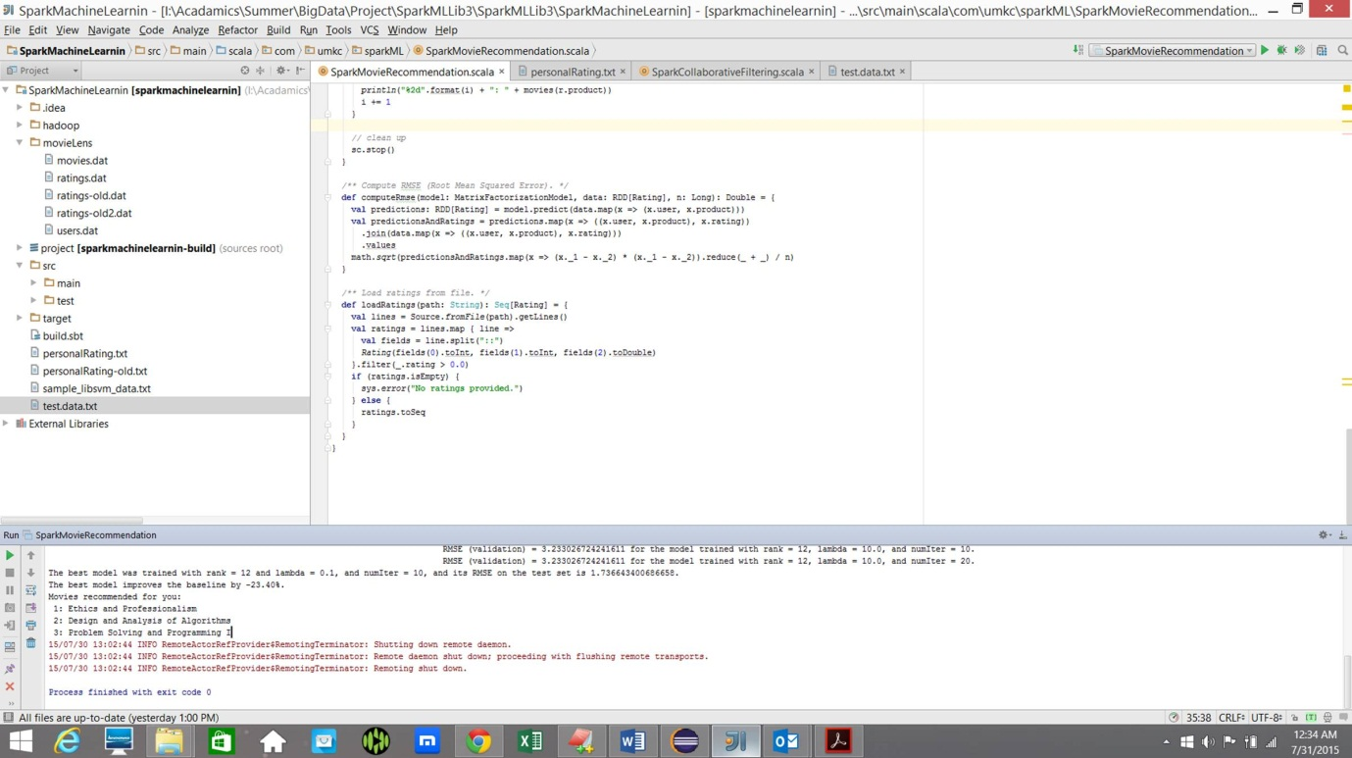

* Command classification using given text classification. We are using machine learning algorithm to classify them.
* Our robot detects two colors, red and green. If it sees red it stops and if it sees green it moves.
* Peer to Peer communication between server and clients.(Android and ios)
* Play music on request.
* Play video on instructions.
* Records the video of the tour and play back on requirement.
* Control the speed of robot based on the accelerometer inputs.
* Control the robot motions based on command input.
* Control the robot movements on speech commands.

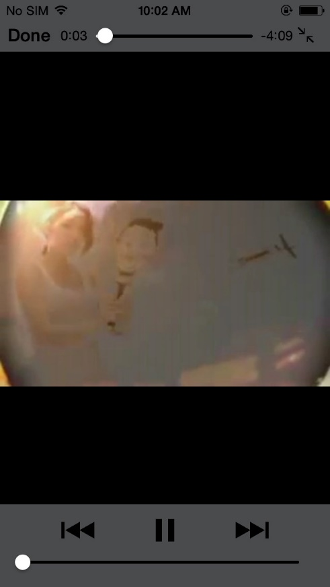 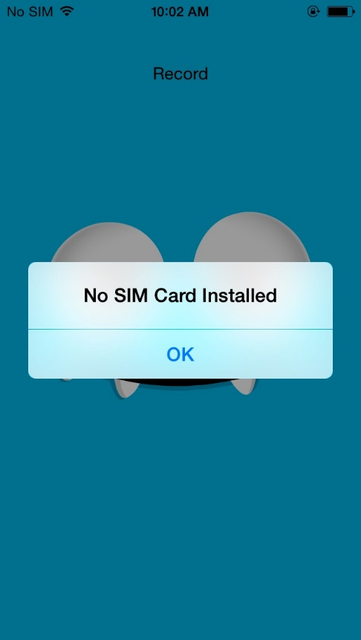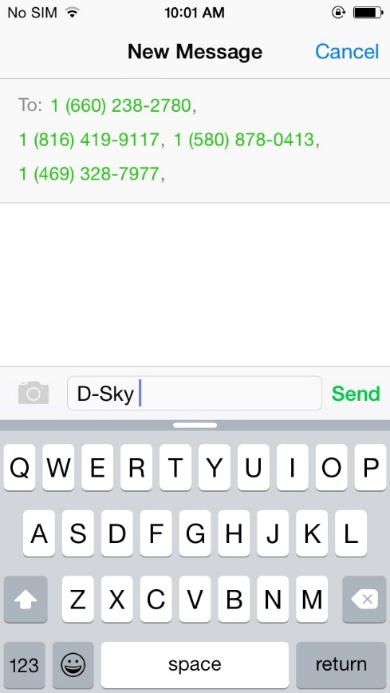 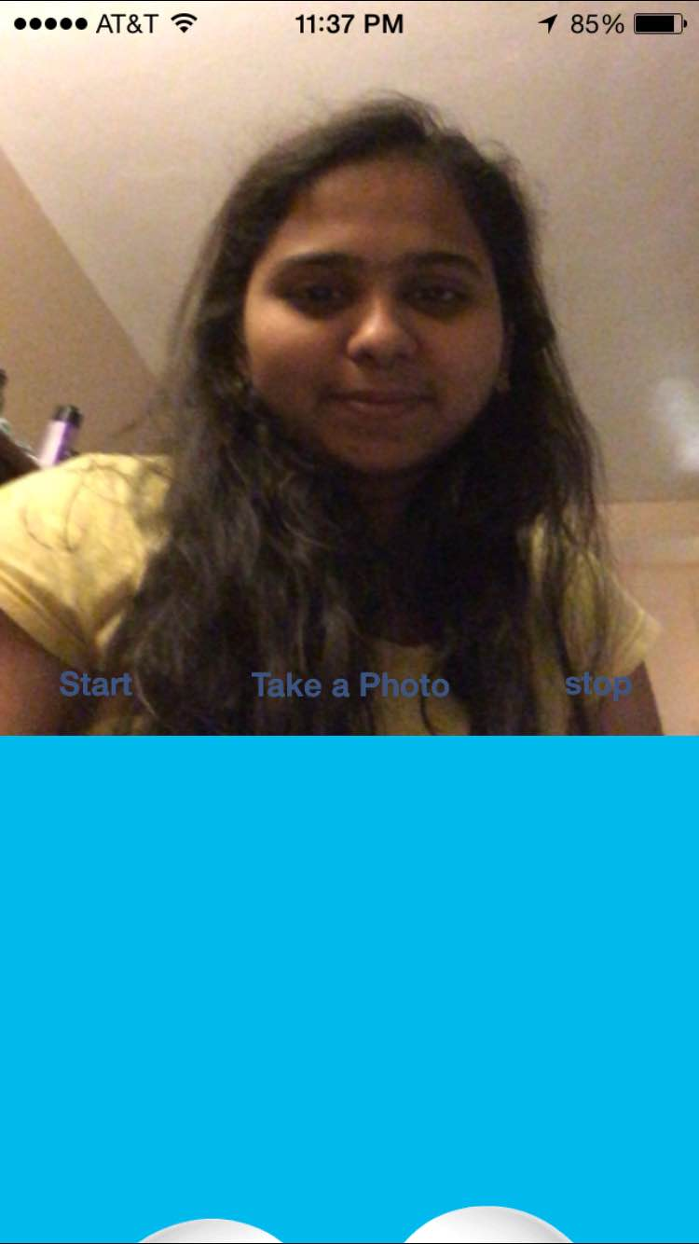

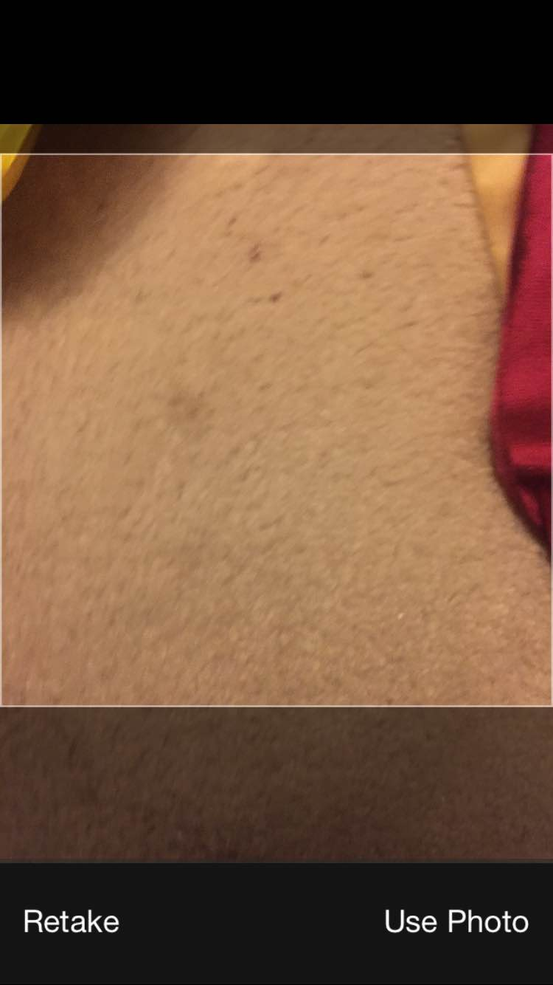 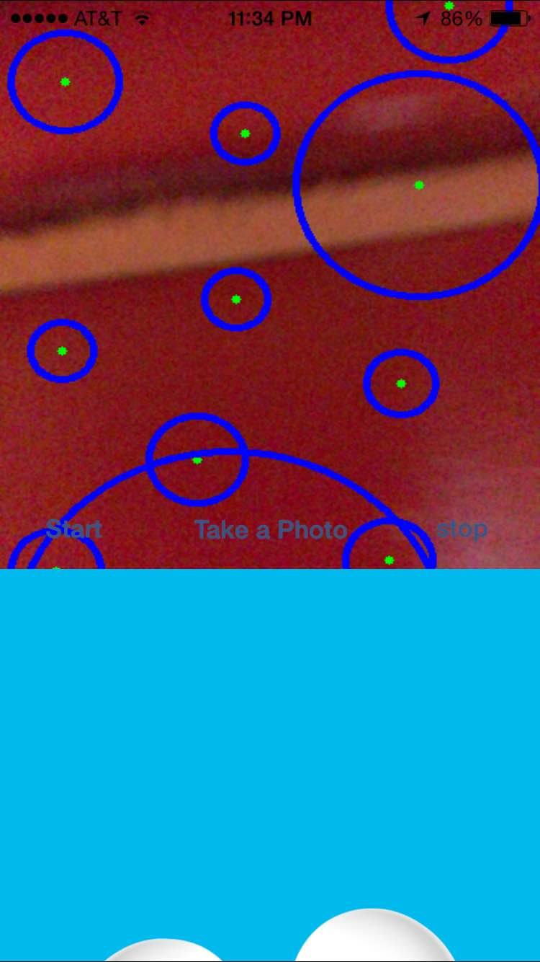

**Implementation Details:**

Technologies we have used:

* Objective C
* OpenCV for C++
* Android
* Spark
* Mongolabs

Algorithms: We have used decision tree algorithm for course recommendation.

**APIs used:**

TTS api for text to speech conversion

Google translator api for speech to text conversion

MAP api for getting coordinates for given location and also current location.

Weather api to fetch the current temperature.

**Results/Evaluations**

Our robot can recommend the courses on the basis of student information and on analysing the sample data in the database in less than 3 seconds.

It makes the suggestion and advice the students whether to go to gym or library or any other campus related places based on the time, climate in less than 4 seconds after analysing the available timings of that place in the database.

**Conclusion:**

Our robot D-SKY is a friendly humanoid robot that interacts with students and helps them in knowing about their university and also it reduces the lot of manual effort and reduces the cost for the university management.

**Future Work:**

As of now we have implemented the basic features. In the future, we will increase the intelligence of the robot. Dynamic route update is not implemented. We can extend that too.

YouTube URL:

<https://www.youtube.com/watch?v=KhC1gyfxasY>

Github URL:

<https://github.com/SandeepBallu/DSKY-FinalSubmission>

**References:**

* Speech to Text and text to speech in MAC
  + Reference: <https://developer.apple.com/library/mac/documentation/UserExperience/Conceptual/SpeechSynthesisProgrammingGuide/SpeechOverview/SpeechOverview.html>
* GPS IOS API
  + <https://developer.apple.com/library/ios/documentation/UserExperience/Conceptual/LocationAwarenessPG/CoreLocation/CoreLocation.html>
* Spark
  + [https://spark.apache.org/docs/latest/api/scala/index.html#org.apache.spark.package](https://spark.apache.org/docs/latest/api/scala/index.html)